Opening Screen: User Will Select the Application at No 2 i.e. Upload RTI Documents

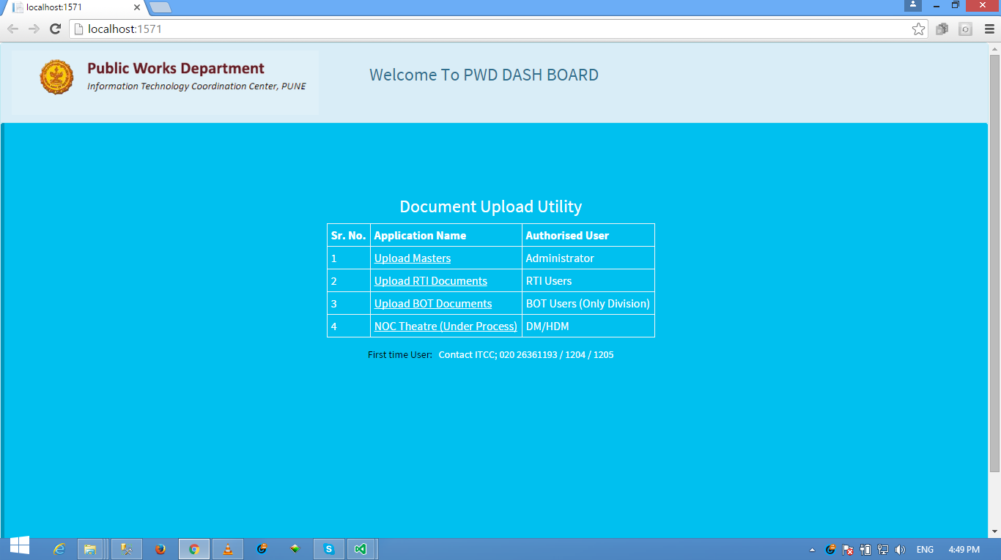

Login Screen: User to Enter the assigned Username and Password

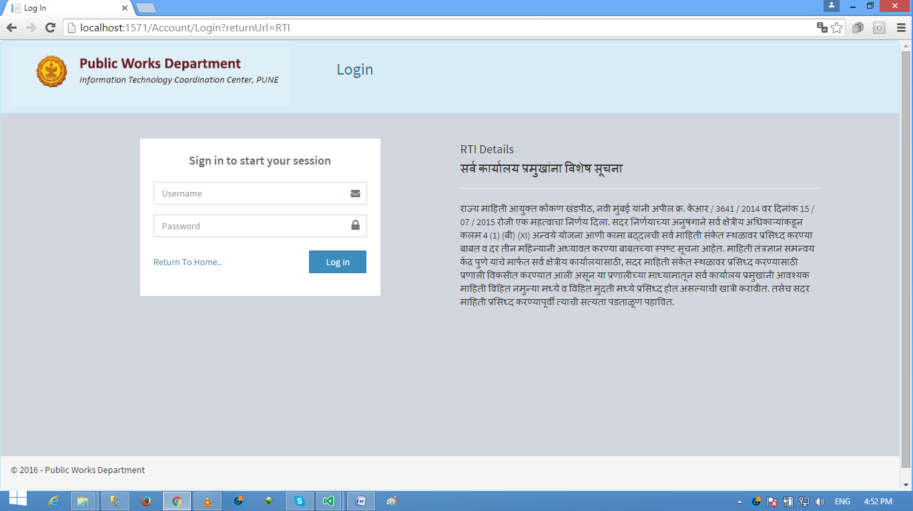

Post Login Screen No 1:

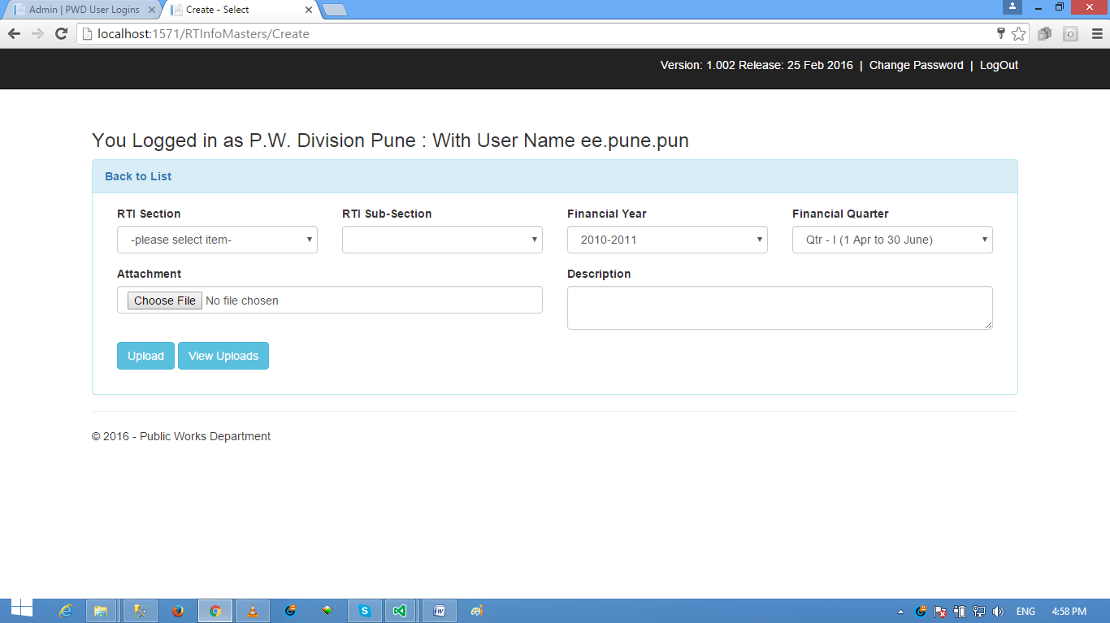

User to Select the desired RTI Section and Sub Section and other details, and then Attach relevant Document. The Document shall be necessarily PDF only. User has the Option to Edit the Description Field which will appear in the Display of Reports to General Viewers.